[21]
Intro to
AI Strategy

- https://www.codecademy.com/courses/intro-to-ai-strategy/lessons/generative-ai-pitfalls/exercises/introduction

Introduction
Our online lives are filled with examples of amazing things
Generative AI
Preview: Docs Generative AI (GenAI) uses AI to create new content from simple text prompts. It can generate various types of content, including text, images, and code.
can do. It’s a powerful tool, and if you’ve used
ChatGPT
Preview: Docs ChatGPT is an AI-powered chatbot designed by OpenAI to generate human-like responses using deep learning.
, Dall-E, or another Gen AI tool yourself you’ve probably seen this firsthand already!
We can probably agree that not every single problem can be solved using AI. However, Gen AI also has some shortcomings even when tackling tasks it’s specifically designed for and generally good at, like language generation. Luckily, many of these challenges are predictable, which means we can avoid or fix them by using Gen AI in the right way, to solve the right problems.
Solutions to these Gen AI challenges range from small tweaks like improving our prompts and adjusting model parameters, to larger mindset shifts like factoring in longterm internal goals and remembering to take a breath in a crowded, exciting field.
This lesson will walk through six pitfalls to look out for when using generative AI to solve a problem, and show you how to avoid them or be aware of risks:
- Generalization & Compression
- Verifiability
- Scope
- Vulnerability
- Future-Proofing
- Quality Control
Avoiding these issues or having a plan in place to mitigate the risks will help to ensure that generative AI is a useful, efficient, and sustainable tool for you. We’ll focus mostly on
Large Language Models (LLMs)
Preview: Docs Large Language Models are artificial intelligence systems that are designed to process and generate human language on a massive scale.
and Generative Pre-Trained Transformers (GPTs) here, but we’ll talk a little about generative image technologies too.


Generative AI Pitfalls

Generalization & Compression: the Catch-22
Before we jump into some more detailed pitfalls and solutions, it’s helpful to start by understanding the core technology that makes generative AI generative. The key is in compression and generalization.

Compression & Generalization
Compression and generalization help determine how the next word is chosen in a language model. (They also sometimes determine how the next pixel is chosen in an image generator, although the most cutting-edge image generators use a slightly different process called stable diffusion.) We’ll walk through the process for a language model.
First, a model is fed lots of data and begins to recognize patterns of which words are often strung together, and with what frequencies. Compression allows the model to not select a word that is probable. For example, question is the most likely ending to this phrase because it’s the actual ending to the famous line from William Shakespeare’s Hamlet:
"To be or not to be: that is the `question`."

Copy to Clipboard
Compression allows the model to give this combination a probability of zero, even though it exists and may be a likely answer.
Generalization allows the model to select a different word combination that it has never specifically encountered before in training data:
“To be or not to be: that is the `consideration`.”
“To be or not to be: that is the `uncertainty`.”
“To be or not to be: that is the `challenge`.”
“To be or not to be: that is the `crux of it`.”

Copy to Clipboard
This is the key aspect of the technology that makes it “generative”: in other words, a combination of words does not need to have existed before to be a possible output of the model. LLMs can recognize and recreate the predictable patterns of syntax to actually generate new sentences that make grammatical sense to humans – not just spit out repurposed fragments of their training data. This is an amazing feature of LLMs!

Hallucinations
The flip side of this technology is that “likely patterns” are not necessarily true facts – untrue results are often called hallucinations. The model has no understanding of whether its sentences make logical sense or represent truthful statements.
An LLM could tell us “The lion chases the llama” because it recognizes a pattern of animal nouns and generalization allows it to swap one animal for another. The sentence makes perfect grammatical sense, and it’s even easy to imagine that scene. But lions and llamas exist on different continents, so the chance of this sentence being true is pretty much zero. That example is easy to catch, but many are not!

Model Temperature
When we talk about increasing the temperature of the model, that means changing probability distributions so that the model will return less and less likely answers. These answers will reflect less of what’s already determined by the data, and instead, generate more novel content that could be produced based on the data. A lower temperature will output more deterministic answers that are more likely to be true. A higher temperature will create more fiction with more unlikely combinations of words.
Model temperature is often referred to as the model’s “creativity”, but it’s good to remember that that’s really a human-intuitive way of describing changes to the math that powers these models.

RLHF
Finally, reproducing likely outcomes includes the good and the bad. In order to keep models from reproducing and amplifying biased information, lots of human time and effort has to go into curating model training data to keep the input data toxicity-free. Additionally, reinforcement learning based on human feedback (RLHF) “corrects” model outputs to minimize bias and inaccuracies in future runs, and also requires lots of human effort. Both of these processes have to occur before a model is released for public use.
Instructions
NOTE: The “lion chases llama” example is pulled from Dr. Kyunghyun Cho’s presentation, “A slight-less-magical perspective into autoregressive language modeling”. You can find the whole presentation here: https://www.youtube.com/watch?v=OZtRlORfd28.

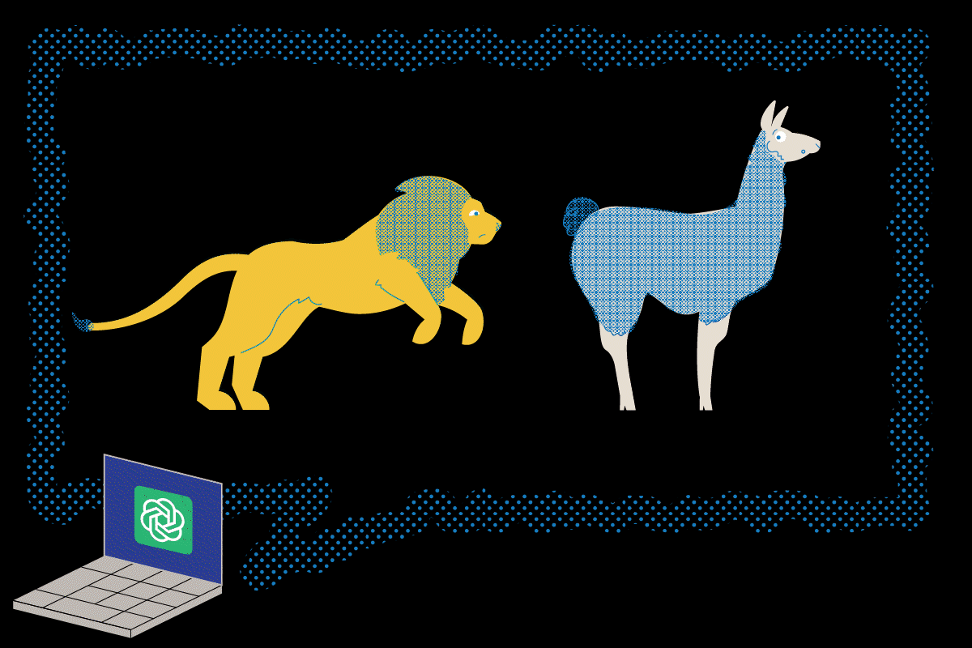

Verifiability
So, compression and generalization is the real catch-22 of generative AI. In order to generate content that doesn’t already exist, we sign up for some amount of risk that what the model produces may be factually inaccurate. There is no escaping the fact that GPTs produce unverified content.
GPTs have generated fake harassment claims and named real people as the perpetrators, made up fake court cases when asked to give a list of precedents, and supported their bogus claims with citations of fake newspaper articles from national papers. Verifying a GPT’s output is a crucial step both in preventing misinformation, and in preventing embarrassing situations and the need for edits, redactions, or public apologies.
One thing that makes it hard to catch falsehoods is that GPTs don’t communicate information in the same way humans do. They don’t sound uncertain, even when they have no relevant training data to work from. GPTs provide information with the same informative, confident, friendly tone no matter what, and they will only say “I don’t know the answer to this” or “I can’t answer this” when they’ve been specifically pre-trained to do so. In other words, LLMs don’t know what they don’t know.
This confident tone, along with the way GPTs are marketed (“impressive!”, “powerful!”, “can ace an MIT course in one go!”), contribute to the phenomenon of authority bias. Authority bias refers to our greater tendency to believe statements that come from individuals or organizations in power, or those we think of as “experts” in a specific domain. We are naturally less likely to disbelieve authority figures and experts – which means it’s doubly important to fact-check GPTs!
So what can we do?
First, always think of yourself as an editor when you use a GPT. GPTs can save us a lot of drafting work, but they do not produce finished content. And while GPT outputs rarely need heavy grammatical editing, they definitely need fact-checking.
Second, use the “temperature” parameter to make outputs more deterministic and less generative. “More deterministic” means the GPT will output information that more closely replicates what it has “seen” before, rather than generating information that’s more inventive. Lowering the temperature of the model means there will be less variation in results, but also less likelihood of unverified material. (For more details, you can refer back to the previous exercise.)
Third, consider what task you’re using a GPT for. For a more creative task, like generating a list of potential content for a newsletter, the more relevant editor’s question might be “is this a good idea?”, rather than “is this factually true?” But if you’re using a GPT in a way where the facts matter, like asking it to write a short bio about a famous person, or return a list of the top five competitors in a certain industry, then it’s critical to have eagle eyes and be ready to fact-check to ensure a truthful output.
Finally, for all of the reasons we’ve covered, make sure to fact-check any output that will be widely shared.



Scope
GPT stands for Generative Pre-Trained Transformer. When we’re considering the scope of a problem, and if
Generative AI
Preview: Docs Generative AI (GenAI) uses AI to create new content from simple text prompts. It can generate various types of content, including text, images, and code.
can be a solution, we’re probably thinking most about the “pre-trained” aspect of a GPT.
GPTs are trained on lots of data. The volume of training data is one of the breakthroughs of the technology in the last few years – it could not have produced high-quality
text
Preview: Docs Generative AI can create blogs, write ad copy, create new content based on text input, and is capable of summarizing and changing the style and tone of text content.
results without the enormous trove of internet data that exists today. However, even with unfathomably large amounts of training data, GPTs don’t know about everything.
One GPT scope issue is that the training data may be outdated, or in other words, limited in temporal scope. As of mid-2023, for example,
ChatGPT
Preview: Docs ChatGPT is an AI-powered chatbot designed by OpenAI to generate human-like responses using deep learning.
only knew about events from 2021 or earlier. Current events prompts may be impossible for the GPT to answer (although it may not recognize this – one user reported asking for a Superbowl recap and getting a detailed answer about a Superbowl that hadn’t happened yet).
Prompts about niche or specialized fields can also pose a challenge. When there are fewer sources to draw from and “remix”, GPTs are more likely to return generated text that is very similar to the existing sources. That’s plagiarism, which can lead to disciplinary or legal action and is definitely best avoided! A better solution might be to ask the GPT to return a summary of a source and cite the source directly.
On the other hand, very broad or general prompts (like “write me a business plan”) yield weak results as well, because the wide scope of training data may make it harder for the GPT to distinguish the relevant or useful patterns in the data. In addition to writing a better prompt, a solution for this issue can be to fine-tune the GPT using training data that’s specific to your situation.
Finally, consider the type of problem you’re trying to solve using a GPT. It is certainly possible to use ChatGPT to write wedding vows, or a eulogy, or a speech to address a national tragedy. It might even write them “better” than you could. But sometimes, bad writing done by a living, feeling human is better than good writing done by a robot using probability distributions.


Vulnerability
Another pitfall to look out for when using GPTs is security vulnerability. This can take a couple different forms, depending on how you’re implementing a GPT. We’ll talk about data security and prompt injections here.

Data Security
No matter what, be mindful of what data you put into a GPT. Companies can log every single piece of data their users input. The data is saved on their servers, used for training purposes, and is often shared with other companies. Exact privacy and data use policies are still in development and often changing, so it’s important to do your own research and understand how your data is stored and where it may be shared to.
Once data is in a GPT, it’s out of your control, so inputting personally identifiable information (PII) into a GPT can make you vulnerable to a serious data breach. OpenAI, for example, had to take
ChatGPT
Preview: Docs Loading link description
offline for about half a day in 2023 to fix a bug that made some users’ credit card information and partial chat history visible to other users.
But what if I want to use my own data to fine-tune a model and improve its performance for a specific task? That’s a great question, and a good use of a GPT! Data can be generalized, anonymized, or otherwise transformed to remove sensitive information before sharing it – if your company has policies for sharing data with third-party or external organizations, a GPT should fall into that category. Local fine-tuning is also a more secure way to use your own data in a GPT.
Finally, if you’re thinking, what’s the point of keeping data out of a GPT? Don’t they have access to everything already? In fact, they don’t! In general, GPTs are (supposedly) trained on publicly available data – like public posts on social media, webpage content, out-of-copyright literature, or news articles from free sources. Anything that requires permission or access – like someone accepting a follow request or paying for a subscription – isn’t supposed to be part of the training data. That being said, as of mid-2023 there are multiple copyright lawsuits in progress by authors who say ChatGPT has been trained on their copyrighted work without their consent. How these lawsuits play out will hopefully give us more insight into ChatGPT’s training process.

Prompt Injection
If you use an API to implement a GPT in your personal project (like creating a helper chatbot for your website), there are additional security concerns. One major concern is prompt injection, which is when a user hijacks the “setup” of a GPT using specific prompts. This can lead to embarrassing situations for a company, or at worst, data breaches and downed sites. We won’t go into technical detail here, but prompt injections can be avoided by following cybersecurity best practices when setting up your own GPT interface.



Vulnerability
Another pitfall to look out for when using GPTs is security vulnerability. This can take a couple different forms, depending on how you’re implementing a GPT. We’ll talk about data security and prompt injections here.

Data Security
No matter what, be mindful of what data you put into a GPT. Companies can log every single piece of data their users input. The data is saved on their servers, used for training purposes, and is often shared with other companies. Exact privacy and data use policies are still in development and often changing, so it’s important to do your own research and understand how your data is stored and where it may be shared to.
Once data is in a GPT, it’s out of your control, so inputting personally identifiable information (PII) into a GPT can make you vulnerable to a serious data breach. OpenAI, for example, had to take
ChatGPT
Preview: Docs Loading link description
offline for about half a day in 2023 to fix a bug that made some users’ credit card information and partial chat history visible to other users.
But what if I want to use my own data to fine-tune a model and improve its performance for a specific task? That’s a great question, and a good use of a GPT! Data can be generalized, anonymized, or otherwise transformed to remove sensitive information before sharing it – if your company has policies for sharing data with third-party or external organizations, a GPT should fall into that category. Local fine-tuning is also a more secure way to use your own data in a GPT.
Finally, if you’re thinking, what’s the point of keeping data out of a GPT? Don’t they have access to everything already? In fact, they don’t! In general, GPTs are (supposedly) trained on publicly available data – like public posts on social media, webpage content, out-of-copyright literature, or news articles from free sources. Anything that requires permission or access – like someone accepting a follow request or paying for a subscription – isn’t supposed to be part of the training data. That being said, as of mid-2023 there are multiple copyright lawsuits in progress by authors who say ChatGPT has been trained on their copyrighted work without their consent. How these lawsuits play out will hopefully give us more insight into ChatGPT’s training process.

Prompt Injection
If you use an API to implement a GPT in your personal project (like creating a helper chatbot for your website), there are additional security concerns. One major concern is prompt injection, which is when a user hijacks the “setup” of a GPT using specific prompts. This can lead to embarrassing situations for a company, or at worst, data breaches and downed sites. We won’t go into technical detail here, but prompt injections can be avoided by following cybersecurity best practices when setting up your own GPT interface.



Future-Proofing
The next pitfall is about hype. While the foundations of large language models have been around for decades, GPT technologies in 2022 and beyond really are a fantastic new technology.
As with any new technology that professes to solve a problem (or, in the case of AI, pretty much any problem), it’s important to think through all the steps of the problem-solving process. Consider not only the issue at hand, but issues that might arise in implementing or maintaining an AI solution.
For GPTs specifically, this may mean thinking through legal concerns like copyright infringement, plagiarism, intellectual property use, libel, or data security. It may mean thinking about the cost of data storage or GPU requirements. It may mean thinking in a specific problem space, like user experience or brand voice, for example.
It may also mean thinking in more general terms about the nature of the problem you’re trying to solve:
- How much time or effort will be saved by automating a process with AI?
- How much time and effort will it take to learn the new approach? Is there a backup if the new process fails?
- If something goes wrong, how great will the consequences be and how quickly will you be able to resolve issues?
- Is there an opportunity cost to automation, like the nuance of a response or the knowledge gained by that interaction?
A good place to start is to make sure that the problem is really a problem. In other words, avoid using AI for AI’s sake. In some cases – especially when you already have a working solution or do not have a clear and defined reason for implementing AI – it’s best to stick with what works.
Using a generative AI-based recommender system instead of a simpler form of
machine learning
Preview: Docs Loading link description
to solve a
classification
Preview: Docs Classification is a supervised technique in machine learning used to categorize data into predefined classes or labels.
problem might be akin to busting out a heavy-duty vacuum cleaner when a simple dustpan and broom would work just as effectively, with less effort.
In other cases, of course, new tools can provide novel and helpful solutions. The key is to consider all the steps of the process, as best you can, to avoid implementing an unsustainable use of new AI technologies.


Quality Control
Finally, related to future-proofing, it’s important to remember that GPTs are not only scientific and technological discoveries, they are products with revenue potential.
Publicity – both techno-optimistic and fear-mongering – is beneficial for AI companies. It adds to the perception that this new technology is a powerful mix of magic and science. In reality, one of the biggest warnings for consumers rarely makes it into the news: AI is a heavily-hyped, heavily-marketed product.
A good solution? Keep learning about large language models, and learn about basic
machine learning
Preview: Docs Loading link description
as well. With all the hype about generative AI, a lot of machine learning advances from the last several years are now marketed as AI. The definitions of a lot of these technologies overlap, but it’s a shame to pay for “fancy new AI” when the driver of a product is actually ML that’s been around for 10-15 years. “Move fast and break things” leaves some things… well, broken. Anyone remember the metaverse?
Being able to conduct your own research and separate marketing claims from actual capabilities and applications is an important skill for successfully implementing AI technologies.
Additionally, as we discussed in the last exercise, be selective with AI solutions, and try to take a problem-solving approach that considers the past, present, and future of the problem. Remember that AI – and indeed no technology – is a silver bullet for a complicated problem. Consider the AI pitfalls we’ve covered in this lesson as part of your process for deciding if, when, and how to implement an AI solution.
Image credit: This image is from the popular webcomics XKCD (https://xkcd.com/2173/).



Recap
- Generalization and compression: Generalization is both a core feature and a core challenge of LLMs because it allows them to produce generated (i.e. original) but also unverified sentences.
- Verifiability: Outputs from LLMs can always contain factually inaccurate information, and LLMs do not know or understand facts. They perform language tasks with confidence and it’s important for humans to be skeptical editors with an awareness of authority bias.
- Scope: GPTs are pre-trained on data that cannot be changed or amended, but they can be fine-tuned on local data to better address specific questions. As with all data-related questions, the quality of the data greatly impacts the quality of the outcomes.
- Vulnerability: Users should not upload sensitive data into GPTs because they are not secure or confidential. Without proper security measures in place, GPT APIs are vulnerable to attacks like prompt injections.
- Future-Proofing: Because of the new and changing nature of LLM and GPT technologies, it’s important to consider from an individual standpoint the costs and benefits of integrating them into workflows.
- Quality Control: It’s critical to remember that new advances in AI are not only scientific discoveries, they are products with revenue potential. Being able to conduct your own research and separate marketing claims from actual capabilities and applications is an important skill for successfully implementing AI technologies.

Next Steps
You’ve completed the Intro to AI Strategy course! What’s next?
Congratulations, you’ve successfully completed the Intro to AI Strategy course! In this course, you learned about six common pitfalls of Generative AI and how to mitigate them when possible. More specifically, you learned to:
- Identify common AI pitfalls:
  - Generalization & Compression
  - Verifiability
  - Scope
  - Vulnerability
  - Future-Proofing
  - Quality Control
- Develop strategies to mitigate AI risks
- Create responsible AI solutions
Your learning journey into AI isn’t over yet! There are plenty of other topics that you can dive into to continue learning. Here are our recommendations for the next steps:

Intro to LLMs
Dive deeper into Large Language Models in our Intro to LLMs course.

Intro to Generative AI
Learn more about the uses of Generative AI, including image and video generation, in our Intro to Generative AI course.

Intro to Language Models in Python
Dive into the technical details of creating Language Models in Python in our interactive programming course Intro to Language Models in Python.

AI Article Hub
Check out these articles to learn more about AI and what you can use it for.
Once again, congratulations on finishing your Intro to AI Strategy course! We are excited to see what you accomplish next.

